**Smart Toy Project**

MISSION1: The car should avoid obstacles.

SOLUTION:UltraSoic_sensor.

MISSION2: Line Following.

SOLUTION:IR Sesor we can put 4 Ir sesor in front part of our car body for more acc.

MISSION3: Use can order the car to move forward or backward for certain length (EX 40 cm).

SOLUTION:we can use speed sensor( optic decoder)(LM393 SPEED SENSOR DETECTION SPEED MODULE) AND CALCULATE THE TIME WE NEED TO MOVE 40 CM)

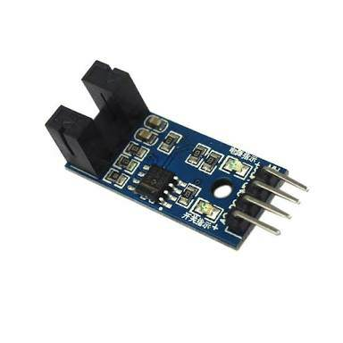

MISSION4: Use can order the car to move right with proper angle (EX 30 degree).

SOLUTION: -we may not use Accelerometer for that aid as we will ot use it again so we can make use of Dc motor driver and choose the right time to make car stop at 30 degree and move forward after that.

MISSON5: While demo the car should move in infinity shape then rectangle shape then circle shape.

SOLUTION:OUR IDEA IS TO MAKE SKETCH IN WHITE SCREEN AND SEND instructions TO B.mod

Inserting like relate to that idea

LINK: [http://www.instructables.com/id/Android-controlled-path-following-vehicle/](https://l.facebook.com/l.php?u=http%3A%2F%2Fwww.instructables.com%2Fid%2FAndroid-controlled-path-following-vehicle%2F&h=ATON9Fwh7aiOcwZVNlEmN0f5TfWuHyyWsWQDEDeUOu_BQ4JgY-1TseGuBULpSElFASo1vz7YTZ5vGUV298EyCr7o1dMP4cPGFF7dQ42qn64qHE3l2k8TlTOJb3w_B8CzkVF9bH1MGOgzjo85) .

WE CAN DOWNLOAD THE APP AND MODULATE THE ADDITIONAL FUTUERS

IN OUR THIRD MEETING WE WILL SHOW THAT FOR OUR MEMBERS

L293 d motor driver shield

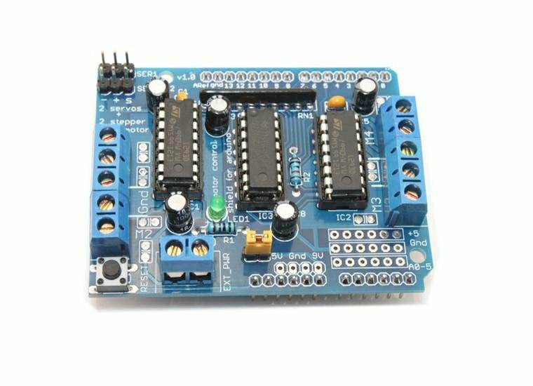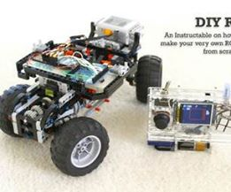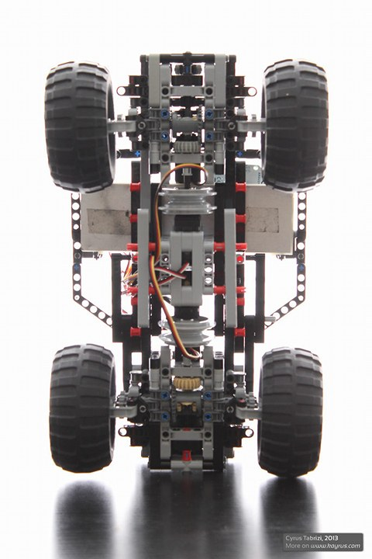

Lets Accelerate.

THE End.